Lakedell Agricultural Society

Christmas Craft Sale
Vendor Application

December 1st, 2018
11am-4pm
$20 a table/Max 2 Tables per vendor

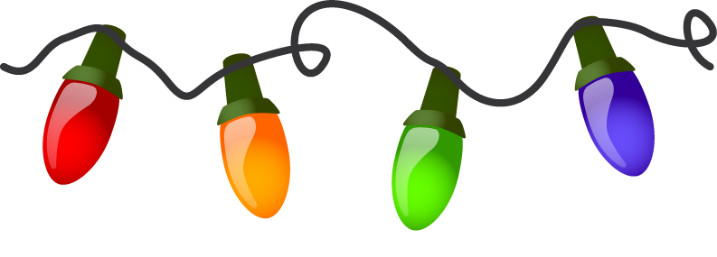
Name _________________________________ Product _________________________________
Address__________________________________________________________________________________
Email _________________________________ Phone Number ______________________

# of tables _____ x $20.00= ______ PD cash/cheque # _______

IMPORTANT:
Table Reservation confirmed only upon receipt of payment.
Payment is due before the day of the event submitted by chq or call the office to pay with credit card 780-586-2505.

Forward request rental to:
Box 166, RR#2 Westerose, AB T0C 2V0 PH: 780-586-2505
Email: lakedellag@xplornet.com

**Doors open for vendor set up at 9:30 am. Tables must be set up before 11am and not taken down until after 4pm.**

