Lakedell Agricultural Society
35th Annual Country Fair
Bench Show Booklet

Saturday, September 3rd, 2011

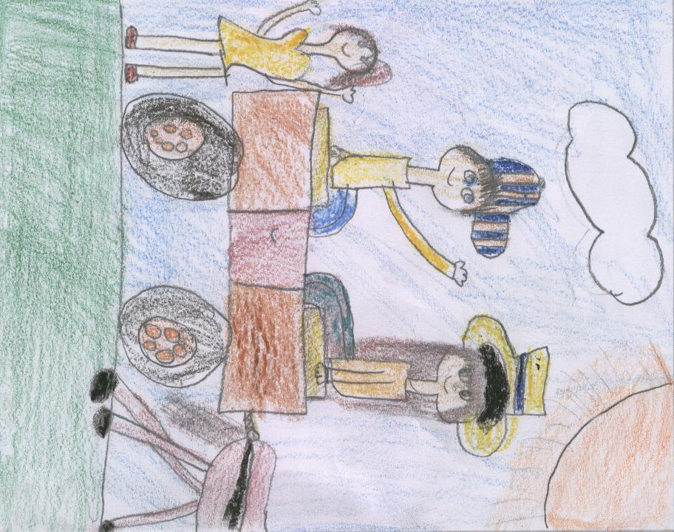

FIRST PLACE: CHLOE FRASER – BRUNO
Grade 2 Lakedell Elementary School

Page 2

LAKEDELL AGRICULTURAL SOCIETY

35th Annual Country Fair



Contact Information:
Box 166, RR #2
Westerose, AB T0C 2V0
Phone: 780-586-2505
Fax: 780-586-2924
e-mail: lakedellag@xplornet.com
Website: www.lakedell.org

OFFICE HOURS
Tuesdays, Wednesdays & Thursdays
9am to 4pm
The Lakedell Agricultural
Society hosted a drawing
contest for students
from Grades 1 to 6 seeking a design for the 2011
Bench Show Booklet cover.

The top two winning artworks are displayed on the front and back cover of our
Bench Show Booklet.

Thank you for the great
interest and many entries
submitted from the
Lakedell, Falun & Pipestone schools.

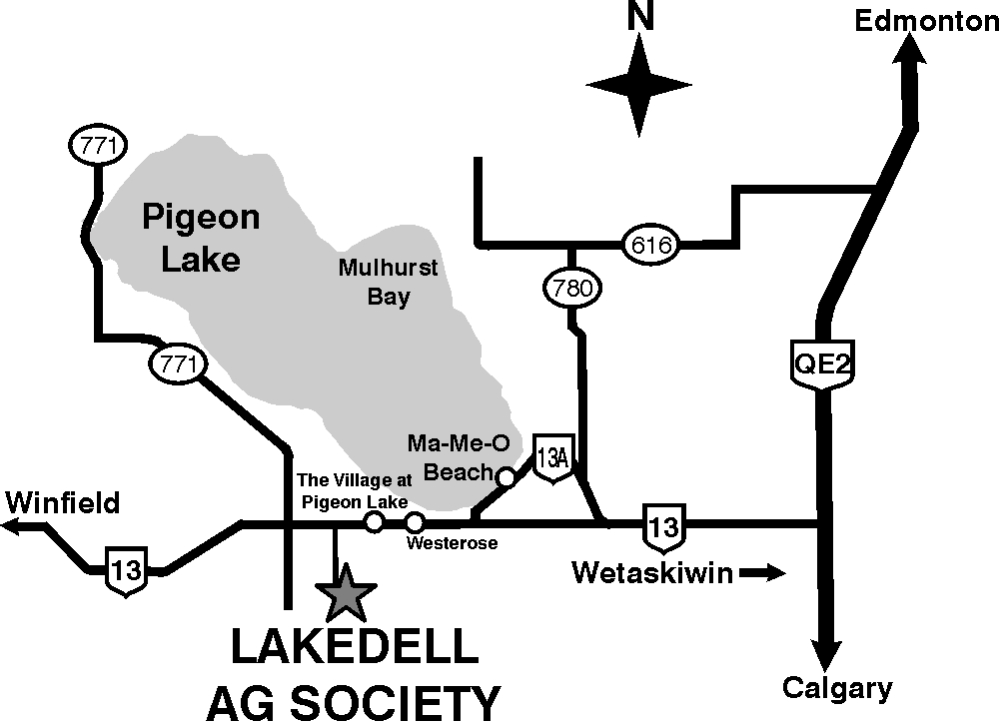

Directions to Ag. Centre

- Lakedell Ag. Society is located just south of Pigeon Lake
- Take QE 2 South from Edmonton or North from Red Deer to Hwy 13 then go approx. 29 Km (16 miles) West on Hwy 13, past the Village at Pigeon Lake to Range Road 12, then South 1.5 Km (½ mile) on RR 12

RULES AND REGULATIONS

1. Entry tags will be available on Entry Day, or may be obtained ahead of time at Lakedell Centre. Office hours are Tuesdays, Wednesdays and Thursdays from 9am to 4pm. All entries must be tagged. Entrants must fill in their own tags, including Section, Class No., and description of exhibit. In Exhibitor No. box please mark your division, as per High Point Trophies Award.
2. All exhibits must be the Bona-Fide work of the exhibitor and must not have been entered in the Lakedell Fair previously with the exception of house plants. Soiled, unfinished or worn out articles will not be accepted. Only one entry per class number. Enter the exact number called for in each class, more or less will disqualify the entry. Juniors may enter in the adult class if no Class No. is available in their section.
3. Entries will only be accepted on Friday, September 2nd from 2pm until 6pm. Judging will take place starting at 6:30pm
4. The Bench Show Most Entries Trophy will be awarded by the Lakedell Agricultural Society. It will remain at Lakedell Centre and a trophy (prize) will be awarded to the winner as a permanent possession.
5. High Point Trophies will be awarded in the following division: Men’s Senior (65 plus), Ladies Senior (65 (plus), Adult Men’s, Adult Ladies, Teen Boys, Teen Girls, Boys 7-12, Girls 7-12, Boys under 7 years, Girls under 7 years. Trophy winners must have entered in more than one class of a particular section to be eligible for high point awards.
6. Exhibits will also be open for public viewing from 9am to 4pm on September 3rd, 2011. Award Presentations at 3:45pm
7. All exhibitors are asked to remove their exhibits between 4pm and 5pm, September 3rd, 2011.
8. Lakedell Agricultural Society will not be responsible for loss or breakage of any exhibit from any cause whatsoever, but the greatest care will be exercised.

ADDITIONAL PRIZES WILL BE AWARDED FOR OUTSTANDING, UNIQUE OR EXCEPTIONAL ENTRIES.

Table of Contents
Section A - Handicraft & Needlework
• Knitting
• Crochet
• Needlecraft
• Machine Embroidery
• Other

Section B - Quilting & Sewing
• Quilting
• Sewing

Section C - Crafts

Section D - Baking

Section E - Preserved Fruit, Vegetables & Wine

Section F - Fresh Vegetables, Fruit & Farm Products
• Fresh Vegetables, Fruit & Farm Products
• Farm Produce
• Grains, Grasses, Legumes

Section G - Flowers & Houseplants

Section H - Art & Photography
• Oils
• Acrylic
• Watercolours
• Photography
⇒ Snap Shot Coloured
⇒ Snap Shot Black & White
⇒ Enlarged (framed)

Section I - Juniors
• Crafts
• Art
• Photography
• Sewing
• Baking
• Vegetables
• Flowers

Section A—Handicraft & Needlework
• Knitting
• Crochet
• Needlecraft
• Machine Embroidery
• Other

Section B—Quilting & Sewing
• Quilting
• Sewing

Section C—Crafts

Section D—Baking

Section E—Preserved Fruit, Vegetables & Wine

Section F—Fresh Vegetables, Fruit & Farm Products
• Fresh Vegetables, Fruit & Farm Products
• Farm Produce
• Grains, Grasses, Legumes

Section G—Flowers & Houseplants

Section H—Art & Photography
• Oils
• Acrylic
• Watercolours
• Photography
⇒ Snap Shot Coloured
⇒ Snap Shot Black & White
⇒ Enlarged (framed)

Section I—Juniors
• Crafts
• Art
• Photography
• Sewing
• Baking
• Vegetables
• Flowers
• Stories

SECTIONS A, B, C
HANDICRAFT, NEEDLEWORK & SEWING
All articles must be clean & pressed.
Articles must be finished and ready to use.
Articles must be judged on workmanship only.
Avoid entering garments that look worn.

SECTION A: HANDICRAFT & NEEDLEWORK
KNITTING:
Class No.
100. Slippers, mitts or socks
101. Baby layette
102. Men’s or ladies cardigan sweater
103. Men’s or ladies pullover sweater
104. Children’s cardigan or pullover
105. Afghan or bedspread
106. Cushion cover
107. Bulky knitting
108. Any article novelty
109. Any article practical
110. Any other article not included above

CROCHET:
Class No.
111. Doilies flat up to 12”
112. Doilies flat 12” - 24”
113. Tablecloth or bedspread (thread)
114. Afghan
115. Cushion cover
116. Shawl
117. Three piece baby layette
118. Rugs
119. Any other article not included above (thread or yarn)

NEEDLECRAFT:
Class No.
120. Hardanger any article
121. Candlewicking any article
122. Crewel any article
123. Petite-point any article
124. Needlepoint any article
125. Needlepoint done on plastic canvas
Continued

126. Cross stitch any article
127. Needlecraft any of the above (Christmas theme)
128. Bunka embroidery dress, scarf, pillow case or cushion
129. Embroidery dress, scarf, pillow case or cushion
130. Silk ribbon or Brazilian embroidery
131. Stitchery any article not included above

MACHINE EMBROIDERY:
Class No.
132. Tablecloth
133. Table Runner
134. Napkins (set of 4)
135. Tea Towels (pair)
136. Tote Bag
137. Bookmark
138. Single article of clothing
139. Any other article not included above

OTHER:
Class No.
140. Beadwork any article
141. Weaving off loom primitive (not rugs)
142. Weaving loom
143. Homespun yarn 2 oz.
144. Rugs hooked new material
145. Rugs any method new material
146. Rugs any method old material
147. Rugs latch hook

SECTION B: QUILTING & SEWING
QUILTING:
Class No.
200. Patchwork quilt hand quilted
201. Patchwork quilt machine quilted
202. Comforter hand tied
203. Wall hanging quilted
204. Jacket or vest quilted
205. Place mats or pot holders quilted
206. Quillo
207. Quilt block
208. Any other article not included above
Continued

SEWING:
Class No.
209. Blouse ladies or child’s
210. Slacks or shorts ladies, men’s or child’s
211. Shirt ladies, men’s or child’s
212. Casual dress ladies or child’s
213. Formal dress ladies or child’s
214. Jacket ladies, men’s or child’s
215. Western wear ladies, men’s or child’s
216. Sports wear ladies, men’s or child’s
217. Sleepwear ladies, men’s or child’s
218. Stretch sewing t-shirt, pants, etc.
219. Adult two or more piece outfit
220. Girl or boy two or more piece outfit
221. Cushion any type
222. Mats, potholders, oven mitts, apron, etc.
223. Recycled items
224. Any article not included above
Hang on hangers where possible

SECTION C: CRAFTS
Class No.
300. Valentine craft
301. Easter craft
302. Fall/Thanksgiving craft
303. Halloween craft
304. Christmas craft
305. Wreath
306. Christmas ornament, religious
307. Christmas ornament, secular
308. Swag
309. Christmas centerpiece
310. T - shirt decorating
311. Jewelry
312. Decorated basket
313. Wall hanging - heat’n bond
314. Wall hanging - any other
315. Folk art
316. Paper tole
317. Silk flower arrangement
318. Doll making
319. Pottery any article
320. Ceramics stained
321. Ceramics glazed
Continued

322. Ceramics any article
323. Leather craft tooled
324. Leather craft soft
325. Woodwork carved
326. Woodwork any large piece
327. Woodwork birdhouse
328. Woodwork any small piece
329. Greeting card rubber stamp
330. Dried flower arrangement
331. Weed arrangement
332. Tole painting
333. Any other article not included above

SECTION D: BAKING
No commercial mixes or fillings.
Place entry on paper plate of suitable size & wrapping.
Clear plastic bag or twist tie or Ziploc bag types.
Name the recipe where possible.

SECTION D: BAKING:
Class No.
400. Bread machine baking 1 loaf any type
401. White bread 1 loaf yeast
402. Brown bread 1 loaf yeast
403. Cheese bread 1 loaf yeast
404. Health bread 1 loaf yeast
405. Raisin bread 1 loaf yeast
406. Sweet bread 1 loaf yeast
407. Dinner buns 3 yeast white
408. Dinner buns 3 yeast brown
409. Cinnamon buns 4 (iced) yeast
410. Cinnamon buns 4 (un - iced) yeast
411. Doughnuts 3 yeast
412. Doughnuts 3 cake
413. Baking powder biscuits 3
414. Fruit bread 1 loaf
415. Muffins bran 3
416. Muffins carrot 3
417. Muffins health 3
418. Cake angel food (not a mix)
419. Cake carrot (un - iced)
420. Cake white batter 8x8
421. Cake chocolate
422. Cake sponge
Continued

423. Cake plain chiffon
424. Cake chiffon other
425. Apple pie (double crust)
426. Raisin pie (double crust)
427. Rhubarb pie (double crust)
428. Lemon meringue pie (bottom pastry)
429. Cream pie (bottom pastry)
430. Cookies shortbread 6
431. Cookies peanut butter 6
432. Cookies chocolate chip 6
433. Cookies sugar 6 (rolled, cookie cutter)
434. Cookies oatmeal 6
435. Butter tarts 3
436. Brownies 3
437. Fudge candy 3
438. Peanut brittle 3
439. Microwave baking whole cake
440. Microwave baking squares 4
441. Special occasion cake (judged on decoration only, could be done on styrofoam etc.)
442. Any other baking not included above
All fresh food must be in plastic bags, closed with twist ties.

SECTION E: PRESERVED FRUIT, VEGETABLES & WINE
All jars will be opened.
Any preserves not properly sealed will be disqualified.
Jars should be pint or quart size.
Standard canning jars with snap lids are preferred.
Label jars - not lids.
Commercial pectin may be used in jams & jellies.

SECTION E: PRESERVED FRUIT, VEGETABLES & WINE:
Class No.
500. Fruit jam 1 kind labeled
501. Fruit jelly 1 kind labeled
502. Freezer jam 1 kind
503. Marmalade 1 kind labeled
504. Dill pickles 1 jar
505. Bread and butter pickles 1 jar
506. Beet pickles 1 jar
507. Sweet mixed pickles
508. Mustard pickles 1 jar
509. Canned fruit 1 jar labeled
Continued

510. Canned fruit 1 jar (home grown) labeled
511. Canned fruit 1 jar (wild fruit) labeled
512. Canned tomato 1 jar
513. Canned vegetable 1 jar labeled
514. Sauerkraut 1 jar
515. Chutney 1 jar
516. Relish 1 jar labeled
517. Antipasto 1 jar
518. Salsa
519. Any other item not included above
520. Wine red 1 bottle labeled (from kit)
521. Wine white 1 bottle labeled (from kit)
522. Wine red 1 bottle labeled (from scratch)
523. Wine white 1 bottle labeled (from scratch)
524. Liqueur 1 bottle labeled

SECTION F: FRESH VEGETABLES, FRUIT & FARM PRODUCTS
All entries should be clean, fresh and of standard size for the type.
All entries should be free from insect damage and blemishes of any kind such as breaks, bruises, sunburn, and dirt.
All entries should be clean but not scrubbed.
Root vegetables should have the tops trimmed to 1 cm above the crown.
All entries should be displayed on paper plates suitable in size and wrapped in plastic twist tie bags or Ziploc bags.

SECTION F:
FRESH VEGETABLES, FRUIT AND FARM PRODUCTS:
Class No.
600. Parsnips 4
601. Carrots 4 of one variety
602. Beets 4 round
603. Beets 4 cylinder
604. Cabbage 1 head green
605. Cabbage 1 head red
606. Cherry tomatoes with stems 6
607. Tomatoes ripe plate of 4 with stems
608. Tomatoes ripe green house 4 with stems
609. Tomatoes green 4 with stems
610. Onions winter storing plate of 4
611. Potatoes red plate of 4
612. Potatoes white plate of 4
613. Potatoes netted gems plate of 4
614. Cucumbers slicing plate of 4
615. Cucumbers pickling plate of 6
Continued

616. Peas 1 variety 6 pods
617. Broad beans 3 pods
618. Beans green 6 pods with stems
619. Beans yellow 6 pods with stems
620. Corn on the cob 2
621. Peppers green 2 with stems
622. Celery 1 plant
623. Scarlet runner beans 3 with stems
624. Purple beans 3 with stems
625. Pumpkin 1 green or orange with stem
626. Squash 1
627. Zucchini 2 (8-10 ins.)
628. Crab apples 6 with stems
629. Eating apples 3 fruits
630. Cooking apples 3 fruits
631. Strawberries ripe 6 with stems
632. Raspberries ripe 6 with stems
633. Currants 4 clusters with stems
634. Plums 4 with stems
635. Turnips summer 2
636. Turnips winter 1
637. Collection of herbs at least 4 kinds in separate jars of water (name variety)
638. Vegetable collection at least 7 kinds (including potato)
639. Any other vegetable not included above
640. Any other fruit not included above

FARM PRODUCE:
Class No.
641. Cheese any kind
642. Eggs 1 dozen
643. Goat products
644. Any other product not included above

GRAINS, GRASSES, LEGUMES:
Class No.
645. Sheaf of grain (any kind)
646. Canola 1 quart
647. Grain 1 quart (last years harvest)
648. Hay (e.g. alfalfa, clover) 3 lb. plastic bag
649. Mixed hay 6 lb. plastic bag
650. Field peas 1 quart
651. Any other not included above

SECTION G: FLOWERS & HOUSEPLANTS
Classes that call for 1 stem or spike can be shown with leaves, buds, and flowers.
Classes that call for blooms - only the flower is judged & should be displayed on a flat plate covered with foil with holes for stems (please include water).
Roses should be shown with stem & leaves attached.
House plants & planters are judged on plants not container, although container should be suitable.
Name the variety where possible.

SECTION G: FLOWERS & HOUSEPLANTS:
Class No.
700. Aster any variety 4 blooms
701. Clematis 2 blooms any color
702. Cornflower (bachelor button) 6 blooms
703. Dahlia 1 bloom under 5” with first set of leaves
704. Dahlia 1 bloom over 5” with first set of leaves
705. Daisy any variety 6 stems
706. Gladiolus 1 spike any color
707. Marigolds over 3”, 4 blooms
708. Marigolds under 3”, 4 blooms
709. Pansy or viola under 2”, 6 blooms
710. Pansy or viola over 2”, 6 blooms
711. Petunia single plain 4 blooms
712. Petunia double 4 blooms
713. Rose hybrid tea only long stem
714. Roses 1 spray shrub variety
715. Rose bowl shown with foliage
716. Snapdragon 3 spikes
717. Strawflower 4 blossoms
718. Sunflower
719. Sweet peas 4 stem one color
720. Sweet peas 12 stems 4 colors 3 of each
721. Zinnia 3 blooms
722. Corsage fresh flowers
723. Arrangement garden flowers viewed one side
724. Arrangement garden flowers center piece (not to exceed 8” in height)
725. Green trailing plants
726. Flowering trailing plants
727. Begonia tuberous
728. Begonia fibrous
729. Cactus flowering
730. Cactus non-flowering
Continued

731. Carnation
732. Geranium
733. Fuchsia
734. Any other plant or flower not included above
738. Planter arrangement 12” and over in diameter
739. Vegetable planter
740. Herb planter
741. Mini planter under 6”
742. Unique planter judged on container
743. Any other planter not included above

PLANTERS:
Class No.
735. Hanging basket
736. Window box
737. Planter arrangement 6-12” in diameter

SECTION H: ART AND PHOTOGRAPHY
Art should be mounted & ready to hang.
Pictures done on paper if not framed should be mounted on stiff backing at least 1” longer than the picture.
Photos should be print size only, panorama size prints acceptable.
All photos should be mounted on stiff white backing with 1/2” border.
Enlarged photos are to be framed.

SECTION H: ART AND PHOTOGRAPHY
ART
Oils:
Class No.
800. Birds
801. Flower
802. Animal life
803. Still life
804. Landscape
805. Other
806. Other (pastels, charcoal, pencil, ink, etc.)

Acrylic
807. Birds
808. Flower
809. Animal life
810. Still life
811. Landscape
812. Portrait
813. Other

Watercolours:
814. Birds
815. Flower
816. Animal life
817. Still life
818. Landscape
819. Portrait
820. Other

Photography
Snap Shot Colored:
Class No.
821. Animals
822. Birds
823. Flowers
824. Still
825. Scenic
826. Sports (action)
827. Humorous
828. Portrait
829. Night photos
830. Generations
831. Story - telling collage
832. Scrapbook
833. Other

Snap Shot Black & White:
834. Animals
835. Birds
836. Flowers
837. Still
838. Scenic
839. Sports (action)
840. Humorous
841. Portrait
842. Night photos
843. Generations
844. Story - telling collage
845. Other

Enlarged (framed):
846. Animals
847. Birds
848. Flowers
849. Still
850. Scenic
851. Sports (action)
852. Humorous
853. Portrait
854. Night photos
855. Generations
856. Other

SECTION I: JUNIORS (Categories: 7-12 years old & under 7 years old)
All junior entries are to follow the same guidelines as the adult entries.

Crafts:
Class No.
900. Valentine craft
901. Easter craft
902. Fall/Thanksgiving craft
903. Halloween craft
904. Christmas craft
905. Christmas ornament
906. Wreath
907. Fabric painting
908. Wrapped gift box
909. Any occasion card
910. Computer designed card
911. Pressed flowers, leaves, weeds
912. Recycled article - paper
913. Recycled article - plastic
914. Recycled article - tin can
915. Bead craft
916. Friendship bracelet
917. Doll of any kind
918. Candle
919. Kite
920. Paper craft
921. Wood craft large (bird house)
922. Wood craft small (popsicle stick)
923. Stuffed toy - kit
924. Stuffed toy - original
Continued

925. Fridge magnet
926. Collection
927. Scale model - kit
928. Scale model - hand made
929. Lego, Mechano, etc.
930. Craft project - from camp
931. Pottery - ceramic or clay
932. Craft made from Playdoh or Plasticine
933. Diorama or scenic display
934. Decorated basket
935. Leather craft - any type
936. Plastic canvas
937. Pom - pom craft
938. Any other craft article

Art:
939. Painting - water color
940. Painting - oil or acrylic
941. Picture - wax crayon
942. Picture - pencil crayon
943. Picture - felt marker
944. Picture - oil pastel
945. Pencil sketch
946. Page from coloring book - any medium
947. Finger painting
948. Print making - wood, potato, etc.
949. Collage
950. Creative computer design
951. Any other article

Photography:
952. Pet
953. Family fun
954. Portrait
955. 4 or more photos that follow a theme or tell a story
956. Scrapbook

Sewing:
957. Tote bag, backpack, etc.
958. Vest
959. Sleepwear
960. Sportswear
961. Crazy hat
962. Boxers
963. T-shirt
964. Kitchen accessory
965. Recycled article
966. Craft sewn from kit
967. Craft sewn original
968. Pants
969. 2 piece outfit

Baking:
970. Decorated cookie -1
971. Decorated cupcake -1
972. Muffins 3 same kind
973. Cookies 4 same kind
974. Squares 4 same kind (non cereal)
975. Squares 4 same kind (cereal based)
976. Lunch kit
977. Any other kind

Vegetables:
978. Collection of 5 garden vegetables
979. Novelty figure made from fresh vegetables
979a. Beets cyclonal quantity - 3
979b. Carrots quantity - 3

Flowers:
980. Garden arrangement - minimum 4 varieties
981. Container - garden vegetables
982. Container - garden flowers
983. Sunflower
984. Weed arrangement

Stories:
985. Fiction - max. 500 words
986. Non fiction - max. 500 words

Lakedell Agricultural Society
35th Annual Country Fair

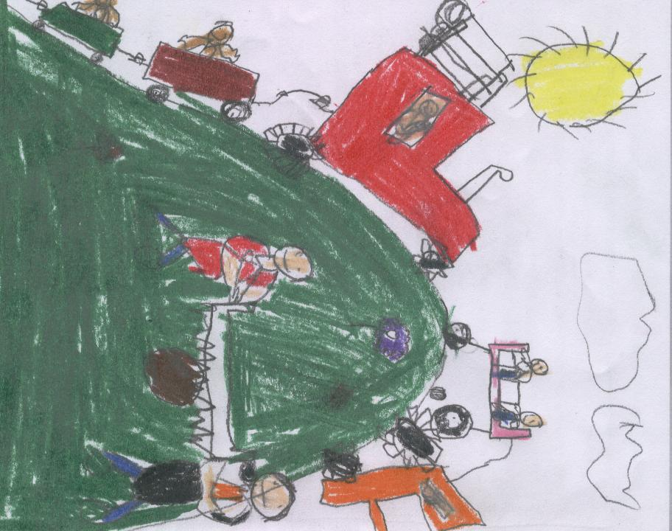

SECOND PLACE: WYATT BAILEY
Grade 2 Lakedell Elementary School

